**Lab 03 - Data unification**

After having ingested the raw data from your data sources into entities, you'll now begin the map, match, and merge process to create a single unified customer profile by merging data from each customer profile source.

To complete this process, you'll first map your ingested entities against a standard model and then select **Primary key** for each of your profiled entities. Next, you'll create your match rule, which will be used to match e-commerce customers with loyalty customers.

Finally, running the merge process will create a single set of unique customers that have matched profiles from eCommerce and Loyalty customer data by using your match rules.

Your objective is to find out how many unique customer profiles that Contoso Retail has across e-commerce and loyalty data.

**Task 1 - Map e-commerce and loyalty contacts to common data types**

1. Map the e-commerce and loyalty data contacts to common data types. On the left menu, select **Unify.**

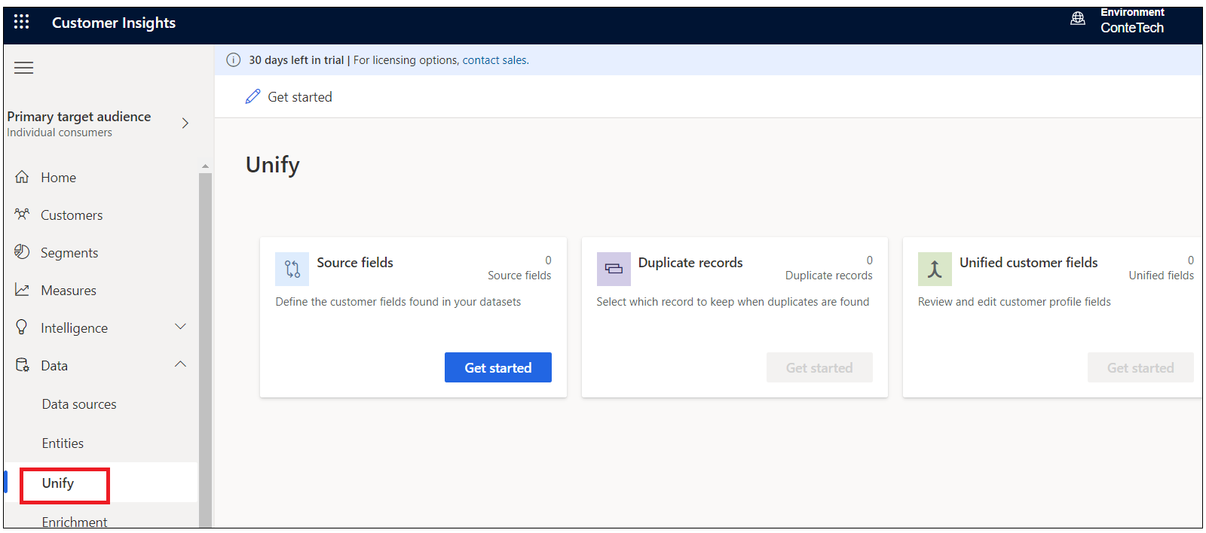

1. Under Source fields, select the **Get Started** button.

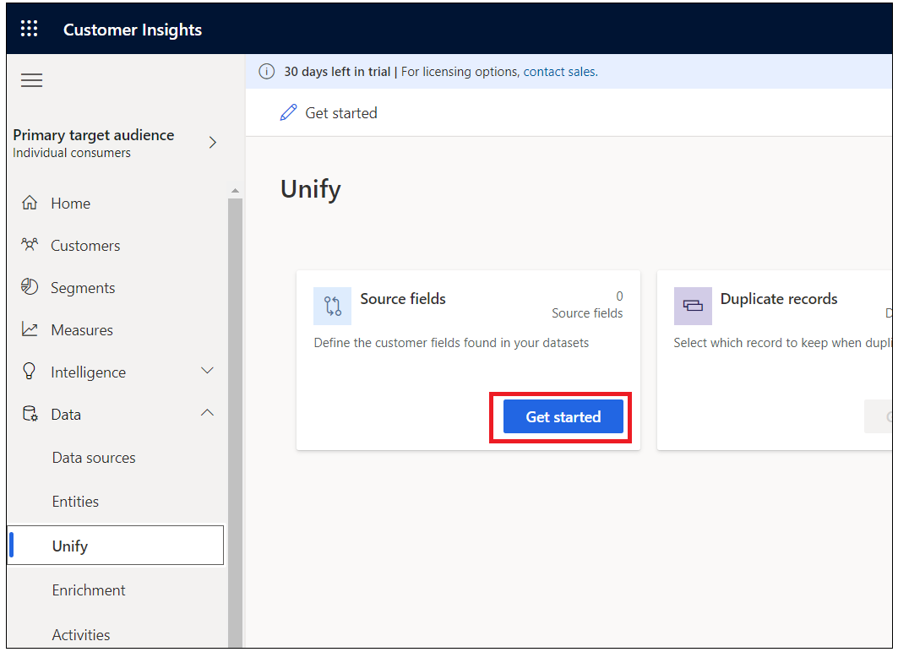

1. Click on **Select entities and fields** .Select the entities that represent the **eCommerceContacts** and **loyCustomers** customer profiles and then select **Apply**.

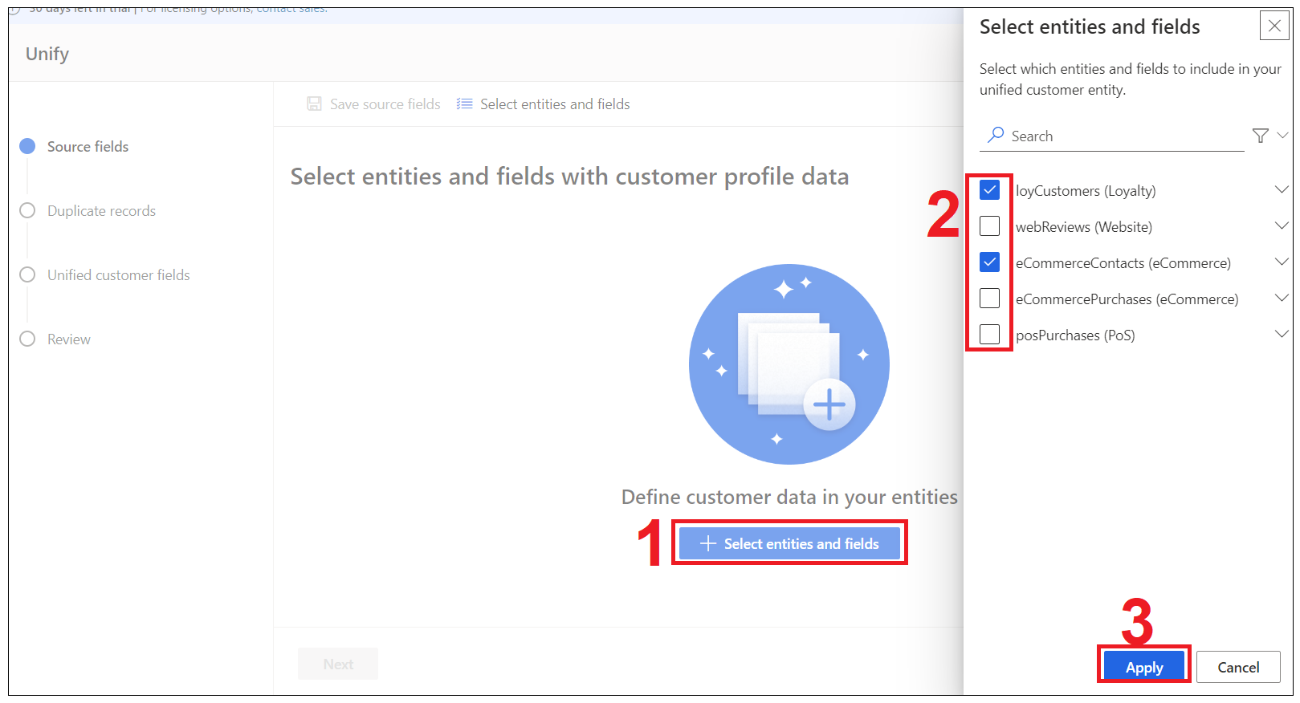

1. You'll now be presented with the mappings of your source entity against standard model types. You can review the types in the table. Choose a primary key for each entity that you've ingested. The primary key must be a unique reference. For **eCommerceContacts**, select **ContactId** as the primary key.

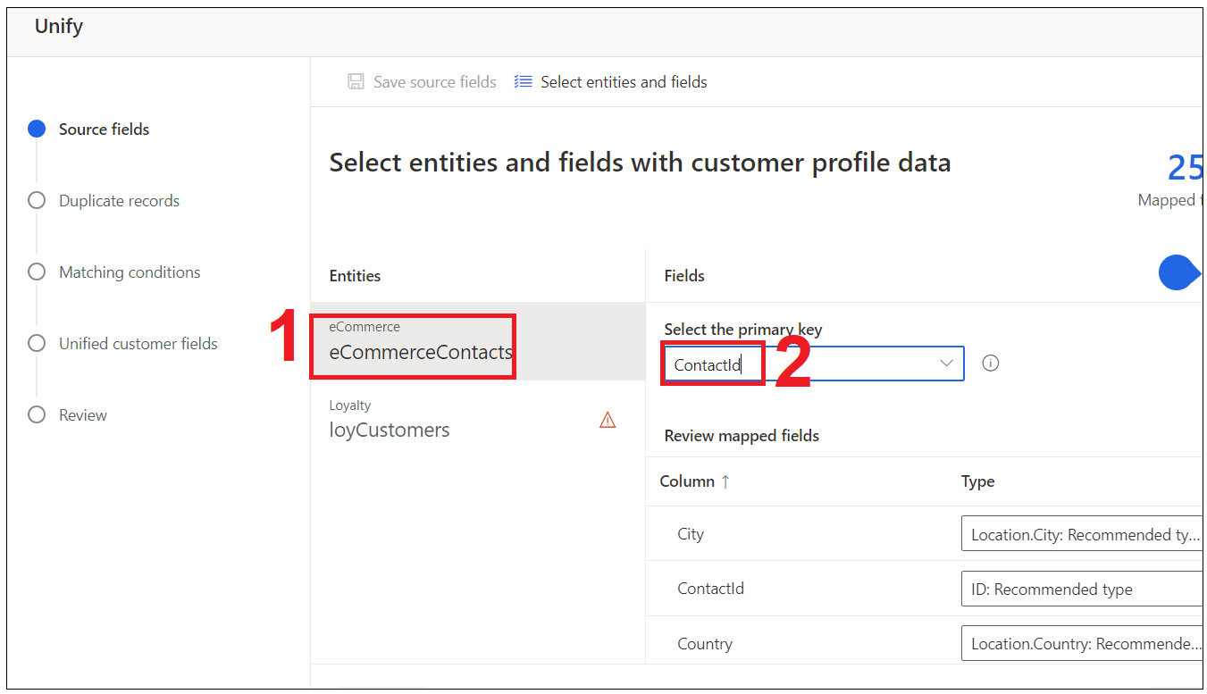12. Now, you may notice there are unmapped fields at the bottom for each entity, you need to map the fields to the common data types in order to merge fields easily later on.

Here is the sample of unmapped fields.

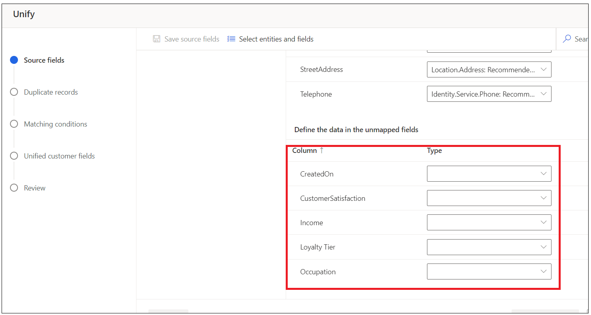

1. Make sure that the fields are mapped, you can type in the **Type** field if you cannot find existing common data type.

CreatedOn : ***CratedOn***

CystomerSatisfaction : ***CystomerSatisfaction***

Income ***:Person. Income***

Loyalty Tier ***: Person. LoyaltyTier***

Occupation ***:Person. jobtitle***

1. Select **loyCustomers** under **Entities** and then set **LoyaltyID** as the **Primary key**.

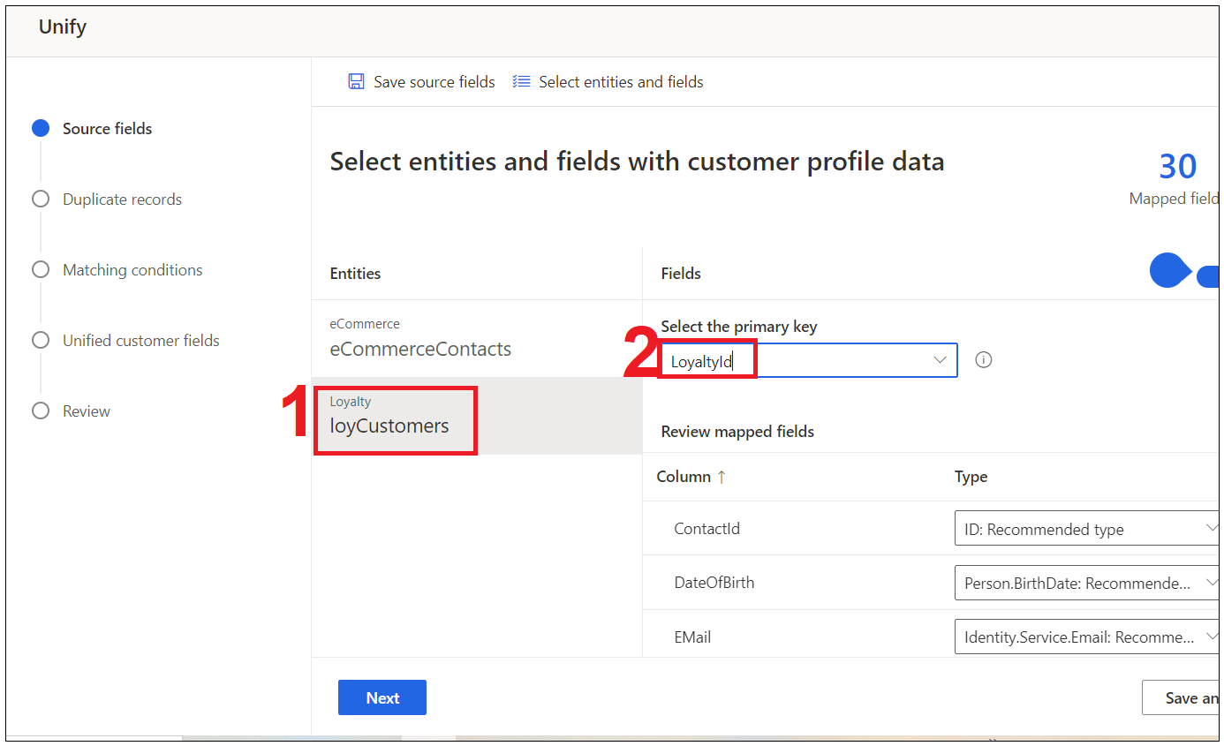2. Now, you may notice there are unmapped fields at the bottom for each entity, you need to map the fields to the common data types in order to merge fields easily later on.

Here is the sample of unmapped fields.

1. Make sure that the fields are mapped, you can type in the **Type** field if you cannot find existing common data type..

CreatedOn : ***CratedOn***

CreditCard : ***person. CreditCard***

1. After you've successfully selected your source fields, select the **Next** button.

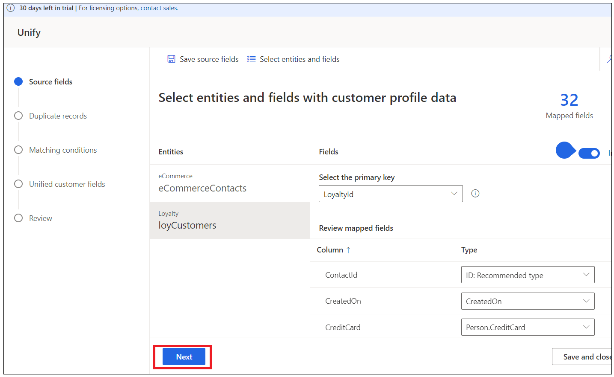

1. After you select the next button, you'll be taken to the duplicate records page. This is where you define any rules you want for handling duplicate records that may exist in your data sources. Our data sources **don't have any duplicate records** so we'll skip this step by selecting the **Next** button to move to **Matching Conditions** stage.

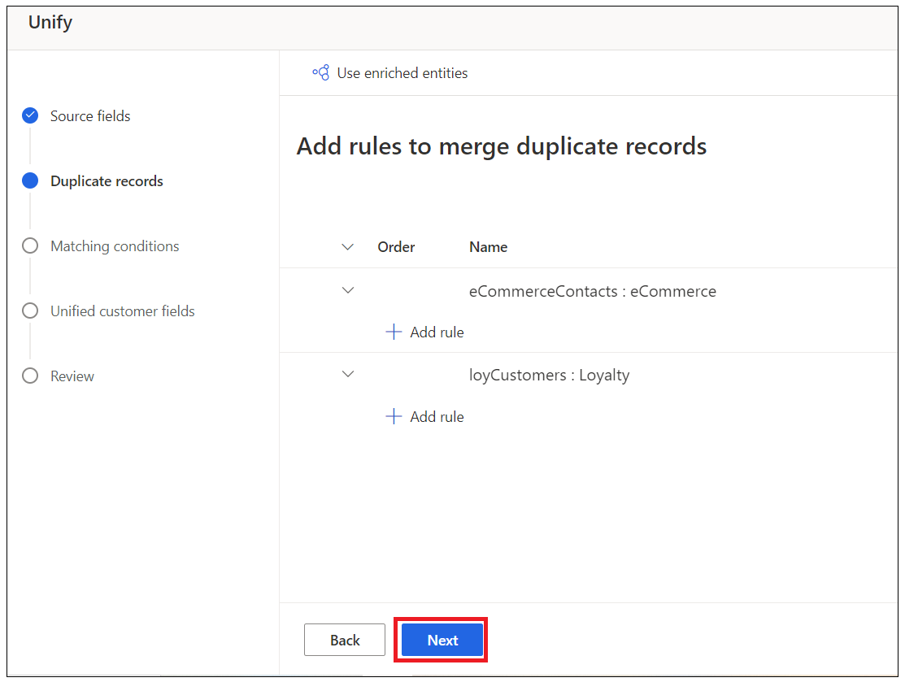

**Task 2 - Specify matching conditions**

For the next stage, you must select the order in which to merge the profiles. You'll be able to merge attributes to ensure that the unified profiles are complete and the priority of which sources to use for those attributes.

1. If you haven't already, ensure that you are on the Matching conditions stage.
2. Ensure that **eCommerceContacts: eCommerce** is set as the first entity on the list and if necessary select **Include all records**.

1. In the **Entity 2** drop-down list, select **loyCustomers: LoyaltyScheme** and then select **Include all records**.

**Task 3 - Create a match rule**

In this step, you'll create a rule that will be used to match records together. Rules can consist of single (for example, based on ID) or multiple (for example, full name, postcode, date of birth) conditions. For this exercise, you'll create a match rule based on full name, postcode, and email.

1. Under the **loyCustomers: LoyaltyScheme** entity, select the **Add rule** button and enter below details.

* Add your first condition by using **FullName**.
* For the **eCommerceContacts** entity, select **FullName** in the **Field** drop-down list.
* For the **loyCustomers** entity, select **FullName** in the **Field** drop-down list.
* Select the **Normalize** drop-down menu and select **Type (Phone, Name)**, which will normalize the values within the **FullName** field.
* Set **Precision** to **Basic** and **Value** to **Low**.
* Add a second condition for email address by selecting **+ Add,** and choosing **Add condition**.

1. For the **eCommerceContacts** entity, select **Email** in the **Field** drop-down list.

* For the **loyCustomers** entity, select **Email** in the **Field** drop-down list.
* Set **Precision** to **Exact**.
* In the **Name** field, enter the name **FullName, Email** for the new rule.
* Select the **Done** button to save the rule.

Customer Insights is now matching customer data from your two sources of customer information, e-commerce contacts and loyalty scheme customers, to identify how many unique customer profiles you would have based on your rules.

1. Select the **Next** button to move to the Unified customer fields stage.

**Task 4 – Unified customer fields**

The Unified customer fields stage is the last stage in the data unification process. Its purpose is reconciling conflicting data and to define the attributes that will be used in your unified customer profile.

A merged attribute is an attribute that exists in more than one data source and represents the same piece of data. For example, you might have **Email Address** in both Web Customers and Loyalty Customer data sources.

Customer Insights will attempt to identify attributes to be merged by using their mapping to the standard data types that you used during the Matching conditions stage.

1. If not there already, ensure you are on the **Unified customer field** stage.

1. Select the chevron on the **FirstName** emerged attribute. You should see that in the FirstName attribute, contacts that are of the same type (for example, FirstName) have been defined as **Merged** and that **eCommerce.eCommerceContactsFirstName** is ranked number one. This ranking denotes that, where you have a matching customer profile in both Loyalty and eCommerce, the first name that is taken from **eCommerceContacts** will be the primary.

1. Since we aren't going to make any changes to the mapping, select the next button to advance to the **Review** stage.

1. Select the **Create customer profiles** button.

1. Click Unify drop down and then select **Unify customer profiles and dependencies**

**Congratulations**! You've successfully ingested, mapped, matched, and merged data from multiple sources within Customer Insights to create a unified customer profile that can be used to gain insights into your whole customer base.